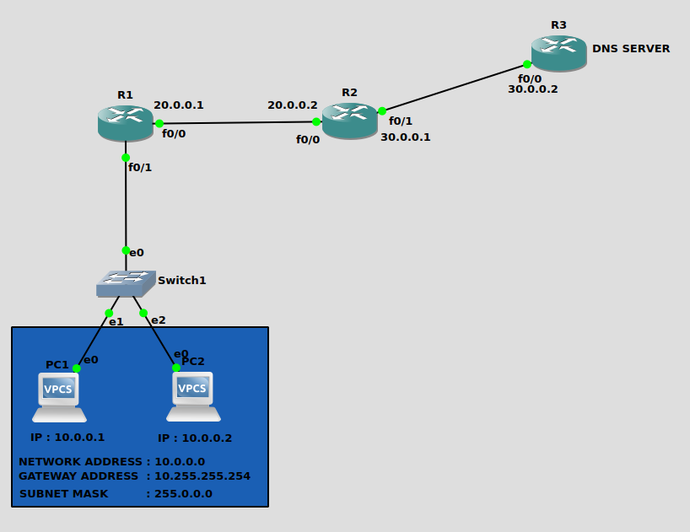
NAYAKANTI SAI MIHIRNATH - 210905368

CONFIGURING PC’s

PC1

ip 10.0.0.1/8 10.255.255.254
ip dns 30.0.0.2

PC2

ip 10.0.0.2/8 10.255.255.254
ip dns 30.0.0.2

CONFIGURING ROUTER’s

R1

config t
int f0/1
ip address 10.255.255.254 255.0.0.0
no shut
end

config t
int f0/0
ip address 20.0.0.1 255.0.0.0
no shut
do wr
end

config t
ip domain lookup
ip name-server 20.0.0.2
ip route 30.0.0.0 255.0.0.0 20.0.0.2
end

R2

config t
int f0/0
ip address 20.0.0.2 255.0.0.0
no shut
do wr
end

config t
int f0/1
ip address 30.0.0.1 255.0.0.0
no shut
do wr
end

config t
ip domain lookup
ip name-server 30.0.0.2
ip route 30.0.0.0 255.0.0.0 30.0.0.2
ip route 10.0.0.0 255.0.0.0 20.0.0.1
end

R3

config t
int f0/0
ip address 30.0.0.2 255.0.0.0
no shut
do wr
end

config t
ip dns server
ip route 10.0.0.0 255.0.0.0 30.0.0.1
ip host pc1.mihir.com 10.0.0.1
ip host pc2.mihir.com 10.0.0.2
end

PING COMMANDS

ping pc1.mihir.com
ping pc2.mihir.com

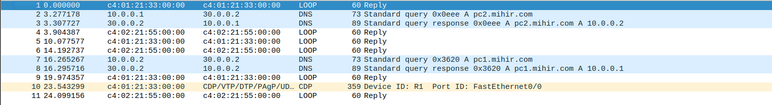

Pinging from PC1 to PC2 and Viceversa using DNS Name sends DNS Query and gets DNS Response.

